What is the MEDDIC sales process?
MEDDIC is an acronym that stands for Metrics, Economic buyer, Decision criteria, Decision process, Identify pain, and Champion. This process emphasizes better customer qualification—in other words, determining whether or not you should expend effort getting a customer into your sales funnel.

Are you failing to consistently close sales? Despite what some people might tell you, the problem may not be your salesmanship or your pitch—it could be the customers you’re selling to.

The MEDDIC sales process helps you know and qualify your audience. You’ll know you’re selling to the right people in the right way, making it easier to close sales. This article will show you how.

MEDDIC methodology overview
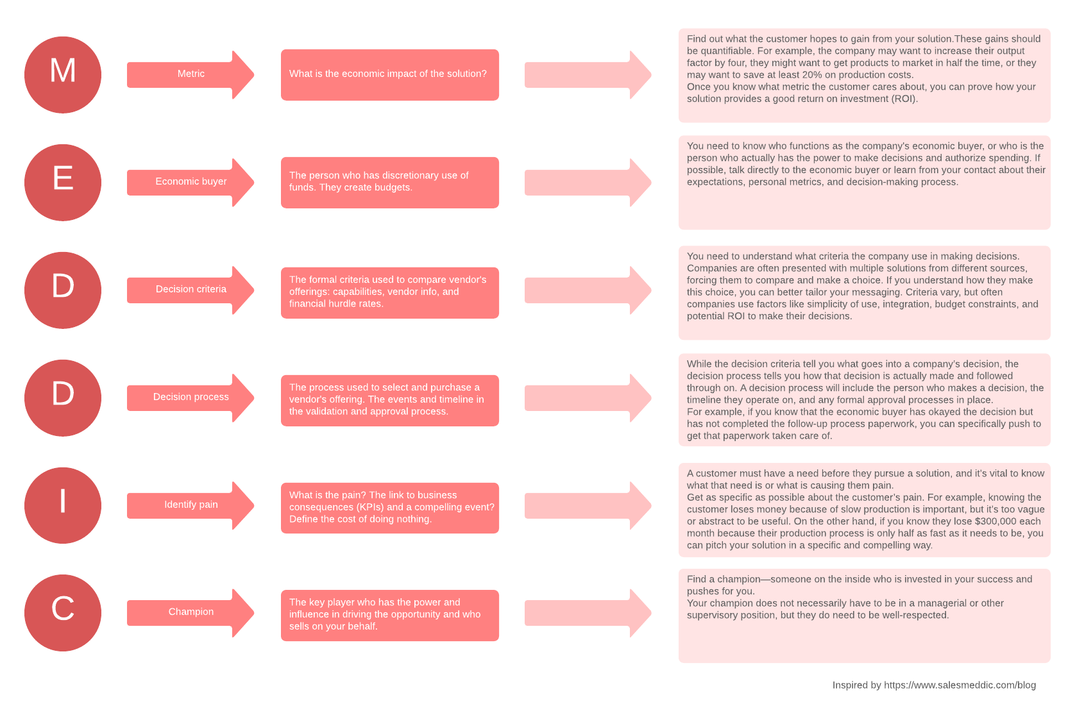

What is the MEDDIC sales process?
The MEDDIC sales process is a B2B sales methodology first developed in the 1990s. This process emphasizes better customer qualification—in other words, determining whether or not you should expend effort getting a customer into your sales funnel. Advocates of the MEDDIC sales methodology argue that pitching to better-qualified customers results in a higher closing rate, thereby increasing sales success.
MEDDIC is an acronym that stands for Metrics, Economic buyer, Decision criteria, Decision process, Identify pain, and Champion—the six concurrent steps used to qualify customers in the MEDDIC sales process.
Metrics
First, find out what the customer hopes to gain from your solution. These gains should be quantifiable. For example, the company may want to increase their output by a factor of four, they might want to get products to market in half the time, or they may want to save at least 20% on production costs.
These metrics enable you to describe the economic benefits of your solution. Once you know what metrics the customer cares about, you can prove how your solution provides a good return on investment (ROI). If you justify your solution from an economic standpoint, you’ll be one step closer to closing your sale.
Economic buyer
You need to know who functions as the company’s economic buyer, or the person who actually has the power to make decisions and authorize spending. Often, you should be talking to someone higher up in the company than your current contact. Knowing the economic buyer and their mindset will help you close sales as the buyer’s veto power makes them the one person who absolutely must be convinced.
If at all possible, talk directly to the economic buyer to learn about their expectations, personal metrics, and decision-making process. In some cases, talking will not be possible, in which case you should try to get this information about the economic buyer from your contact. Use this information to make the sale palatable to the buyer, even if they will not be directly affected by it.
Decision criteria
You also need to understand what criteria the company uses in making decisions. Companies are often presented with multiple solutions from different sources, forcing them to compare and make a choice. If you understand how they make this choice, you can better tailor your messaging.

Criteria vary, but often companies use factors like simplicity of use, integration, budget constraints, and potential ROI to make their decisions. If the company does not already have formally defined decision criteria, you can urge them to put it to paper. This step lets you prove that you can meet all their criteria, in turn showing that there’s no reason they shouldn’t agree to a sale.
Decision process
While the decision criteria tell you what goes into a company’s decision, the decision process tells you how that decision is actually made and followed through on. A decision process will include the person who makes a decision, the timeline they operate on, and any formal approval processes in place.
When you know the decision process, you are much less likely to lose a sale due to stagnation. You know exactly what needs to take place on the company’s side to close the sale, so you can work to meet those conditions. If, for example, you know that the economic buyer has okayed the decision but has not completed the follow-up process paperwork, you can specifically push to get that paperwork taken care of, thereby closing the sale.
Identify pain
A customer must have a need before they pursue a solution, and it’s vital to know what that need is or what is causing them pain. This pain can manifest in many ways, including high costs, slow production, and low revenue. Identify the pain the customer is experiencing, and then identify how your solution can relieve that pain. What will happen if they don’t decide on a solution or if they make a bad decision? And how will your solution fix it?
Get as specific as possible about the customer’s pain. For example, knowing the customer loses money because of slow production is important, but it’s too vague or abstract to be useful. On the other hand, if you know they lose $300,000 each month because their production process is only half as fast as it needs to be, you can pitch your solution in a specific and compelling way.
Champion
Find a champion—someone on the inside who is invested in your success and pushes for you. The champion will likely be the individual most affected by the company’s pain or the person who stands to benefit the most from your solution. Because they want your solution, they want you to be successful and will use their influence to sell the solution from the inside.
Your champion does not necessarily have to be in a managerial or other supervisory position, but they do need to be well-respected. Having an employee known for being lazy and selfish advocate for you might not be in your best interest. But having an employee with influence and respect in your corner can make a world of difference in helping you close that sale.
NOTE: there is also a new variant MEDDPIC and the P stands for “Procurement Process” – do you know the process, steps, people and timelines for how the end customer will procure your solution. This can involve lots of different teams – reviewed, budget holders and can create enormous delays if you don’t understanding how they handle invoices, purchase orders, do you need to be setup as a preferred supplier etc.

MEDDIC strategy map example
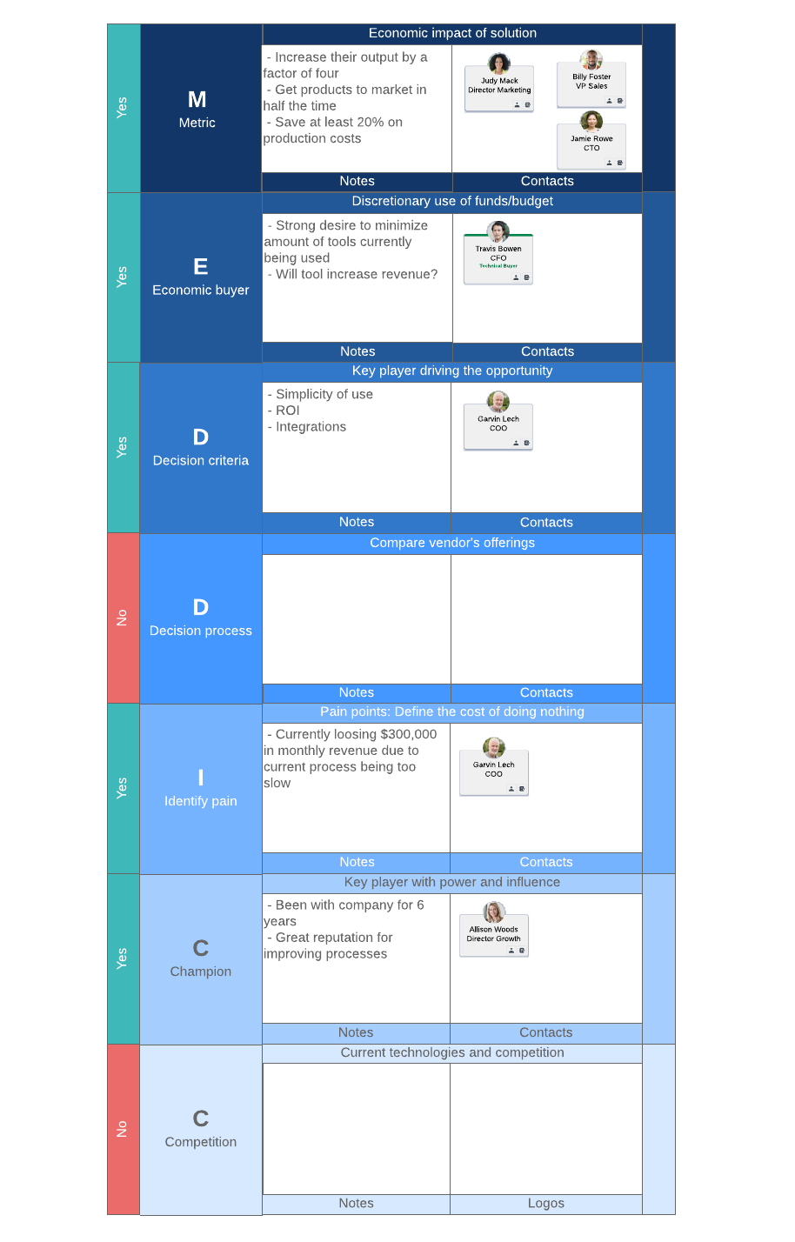

Why use the MEDDIC sales methodology?
The MEDDIC sales process serves as a simple checklist for your sale. It ensures you have all the information you need, and the simple acronym makes it easy to remember if there’s anything else you need to learn. Because the MEDDIC sales process relies on attaining knowledge rather than using sales tricks, it’s easy to implement even for individuals who don’t consider themselves particularly “salesy.”
Moreover, the MEDDIC sales approach gives you the information you need to accurately qualify your leads. As you learn more about your customer, you’ll know whether they’re a worthwhile investment of your time. This approach, in turn, will help you more accurately forecast your sales as you won’t be wasting time keeping unwinnable leads in your sales pipeline.

MEDDIC and the sales process
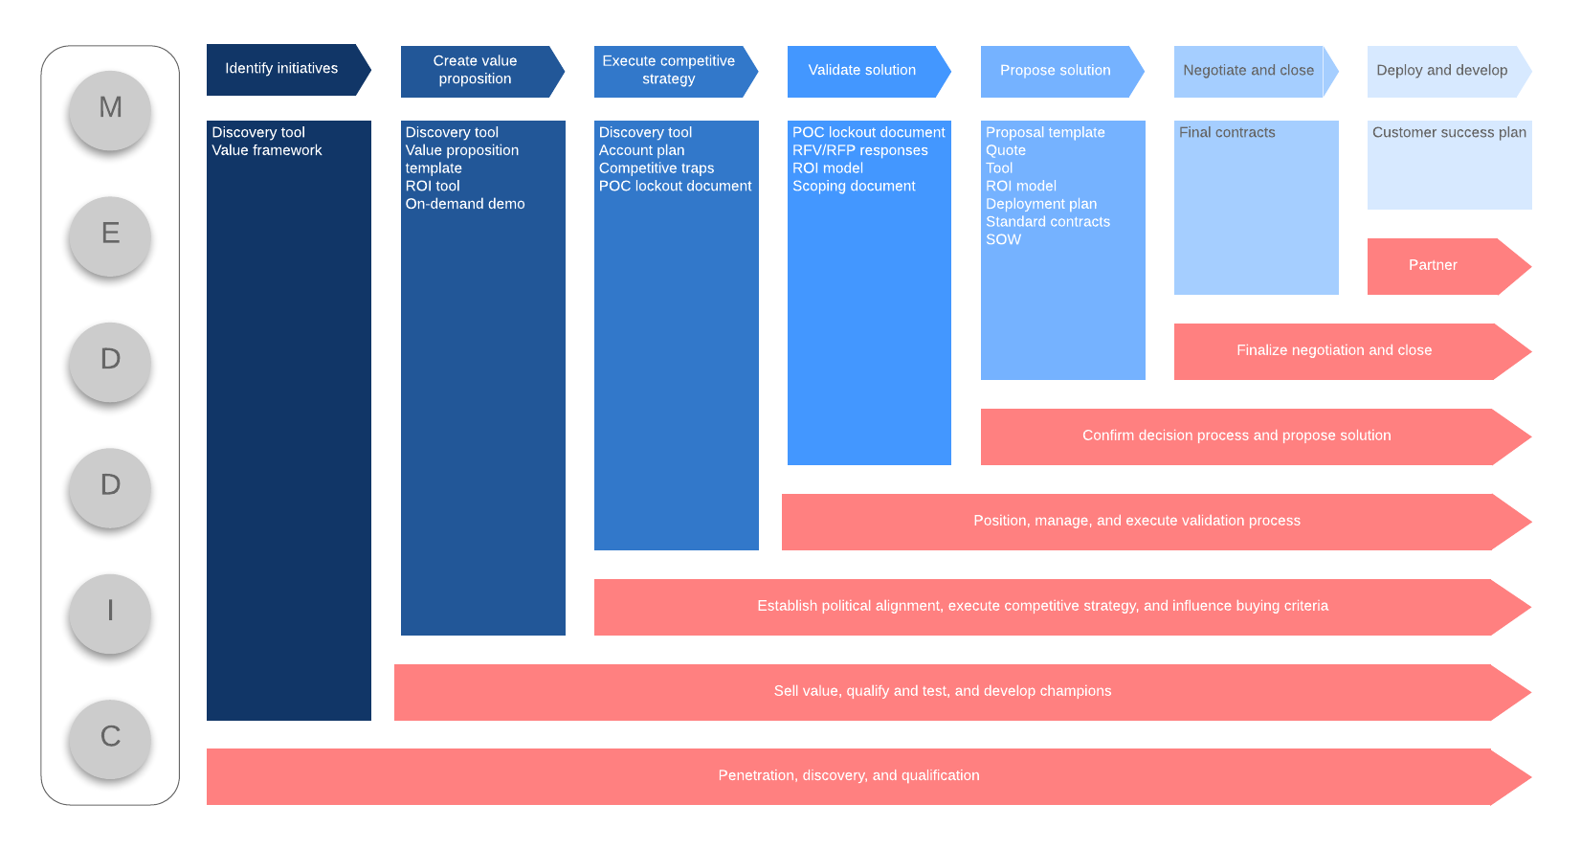
https://www.lucidchart.com/blog/close-more-deals-with-meddic-sales-process

